KUMARAGURU COLLEGE OF TECHNOLOGY

24ADT015-FINANCE, ECONOMICS AND MARKETING

NAME : Nishanth P
ROLL NO : 24BAD405

Market Research - Environmental Scanning

Market research and environmental scanning are crucial activities for any organization aiming to develop effective strategy and maintain a competitive edge. Environmental scanning, in particular, involves systematically monitoring the major external forces that can affect a company's operations and performance. This process helps strategists identify opportunities to exploit and threats to mitigate. Two of the most widely used frameworks for structured environmental analysis are the PESTLE analysis and Porter's Five Forces.PESTLE Analysis
The PESTLE
The PESTLE analysis is a strategic framework used to evaluate the macro-environmental factors that influence an organization. The acronym stands for Political, Economical, Social, Technological, Legal, and Environmental factors. By systematically assessing these six areas, a company gains a comprehensive understanding of the external landscape, which is essential for long-term planning and decision-making.
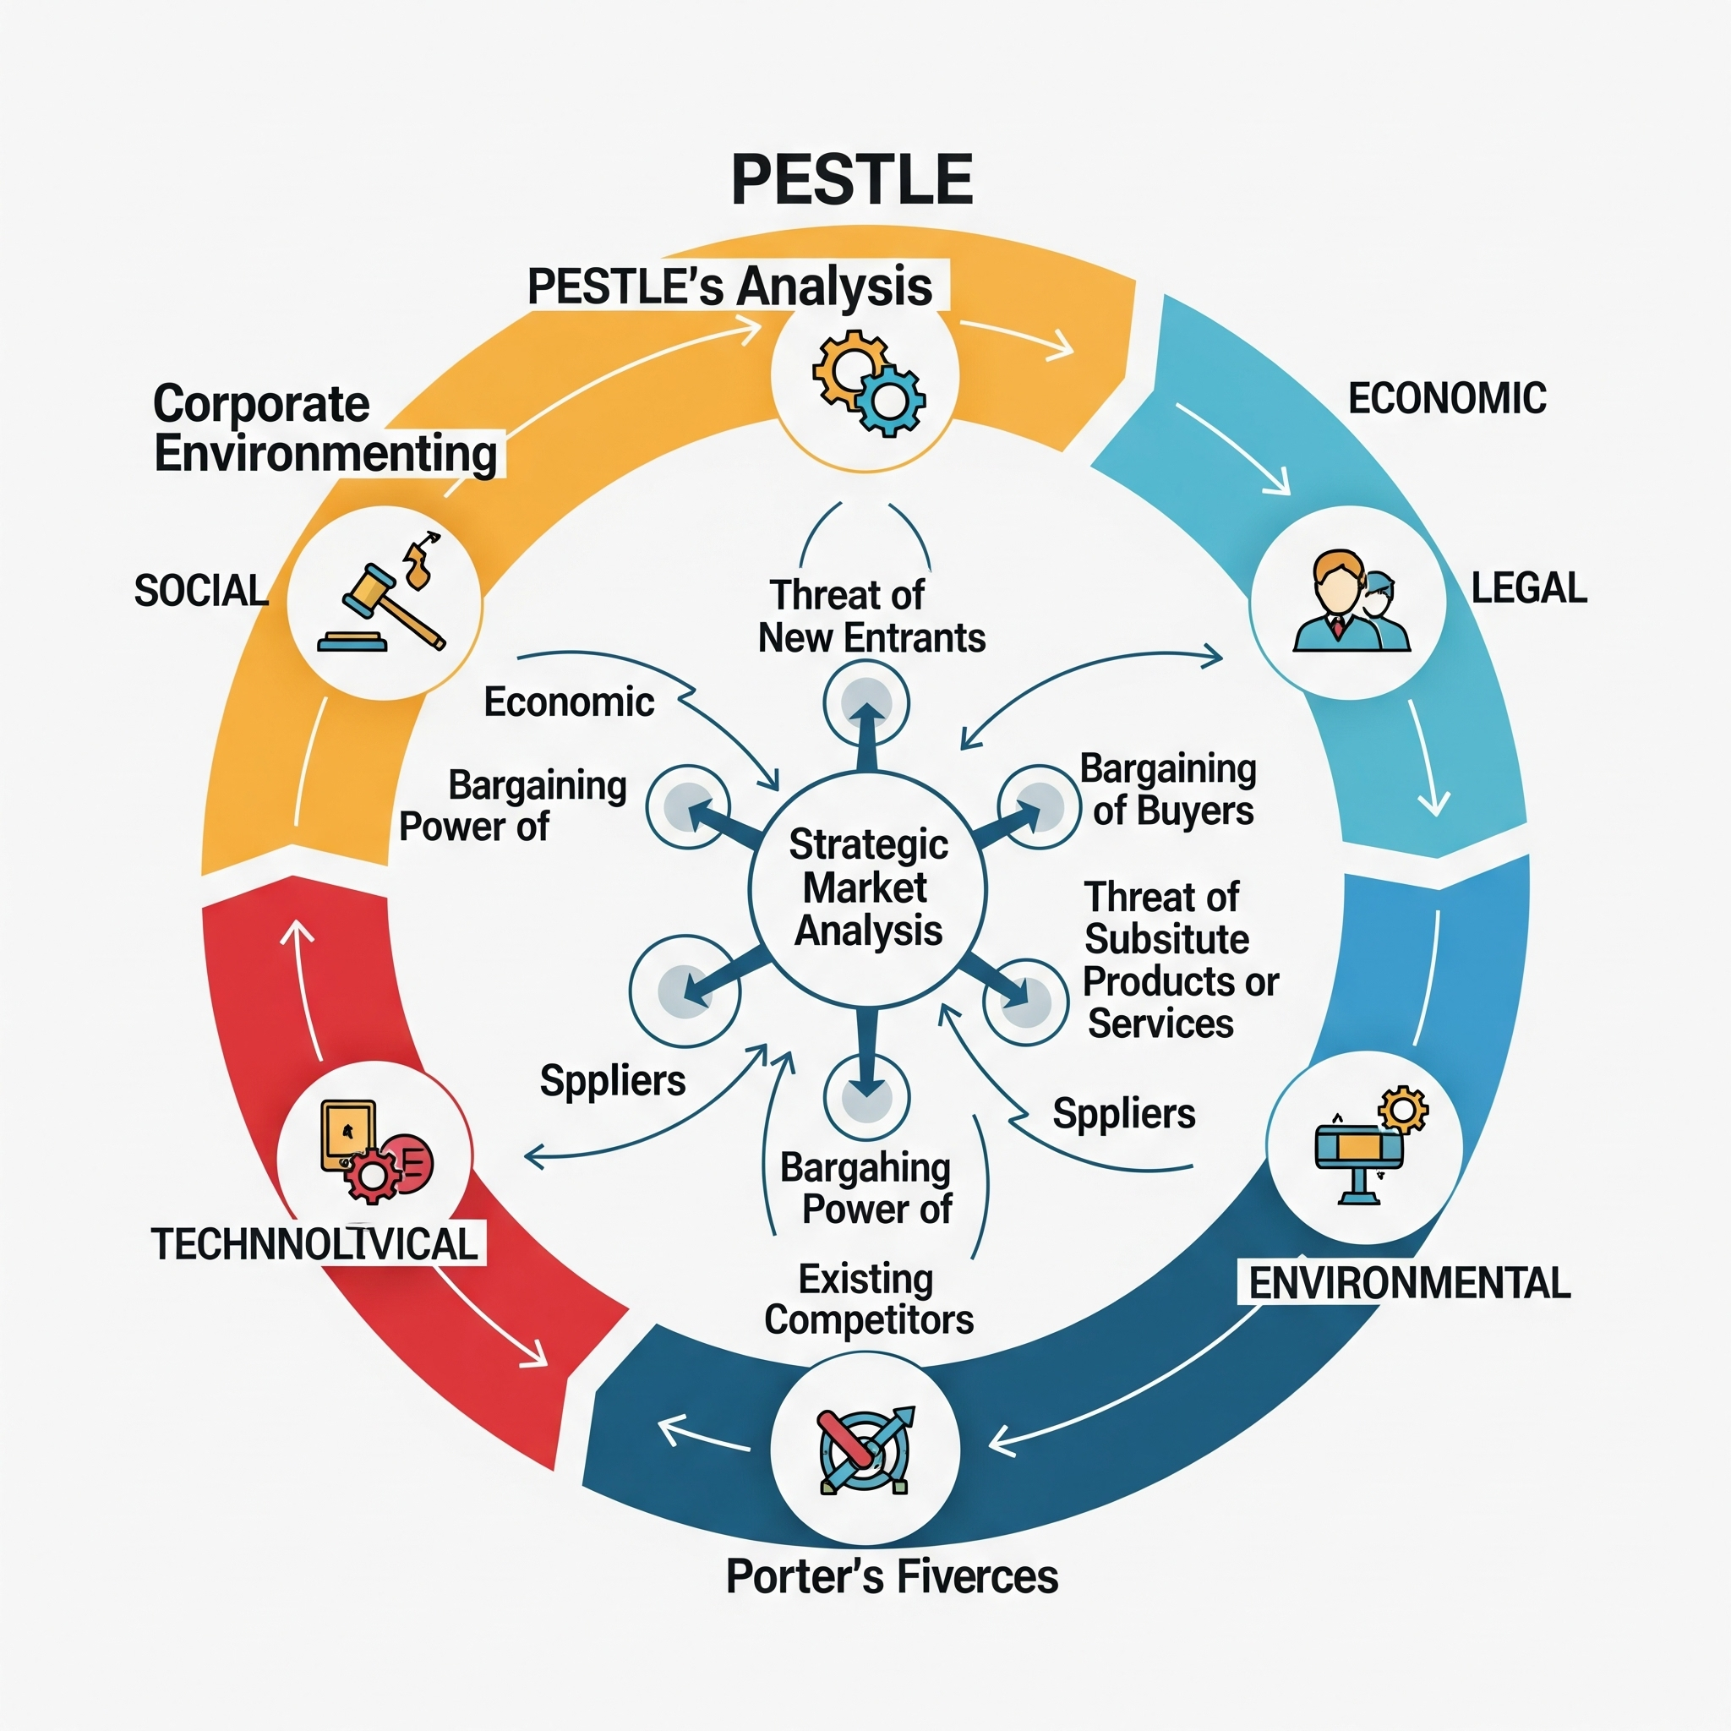
Factor | Definition
Political | The degree of government intervention in the economy, including tax policy, trade tariffs, fiscal policy, political stability, and regulations.
Economical | Factors that determine the economy's structure and performance, such as inflation rates, interest rates, exchange rates, economic growth, and consumer disposable income.
Social | Cultural characteristics, demographics, and attitudes of the population, including population growth rate, age distribution, career attitudes, and health consciousness.
Technological | The pace of innovation and technological change, which can affect production, distribution, and marketing. This includes R&D activity, automation, and access to new technologies.
Legal | Laws and regulations that affect business operations, such as employment laws, consumer protection, anti-trust laws, discrimination law, and health and safety legislation.
Environmental | Ecological and environmental aspects, including climate change, weather, geographical location, pollution control, resource depletion, and sustainability practices.
Related Diagram: A typical PESTLE diagram is a circular or radial chart where the six letters (P, E, S, T, L, E) are placed around a central point representing the business or product being analyzed. Each factor is usually linked to a brief description or a set of bullet points detailing relevant trends and issues. This visual representation emphasizes that all factors are interconnected and influence the central entity.

Example Scenario: Consider a company planning to launch an electric scooter in a new country.
- Political: The government offers tax subsidies for electric vehicle purchases (Opportunity).
- Economical: High-interest rates make loans for scooter purchases more expensive (Threat).
- Social: Urban populations are increasingly concerned about pollution and traffic congestion (Opportunity).
- Technological: Battery technology is rapidly improving, promising longer range and faster charging (Opportunity).
- Legal: New strict import tariffs are imposed on components from the manufacturing country (Threat).
- Environmental: There is a growing consumer preference for sustainable transport options (Opportunity).
Porter's Five Forces

Porter's Five Forces framework is a micro-environmental scanning tool used to analyze the competitive structure of an industry and determine its profitability potential. Developed by Michael E. Porter, it identifies five forces that shape every market and industry: Threat of New Entrants, Bargaining Power of Suppliers, Bargaining Power of Buyers, Threat of Substitute Products or Services, and Intensity of Rivalry Among Existing Competitors. Analyzing these forces helps a company position itself to leverage its strengths and protect itself from competitive pressure.
Force | Definition
Threat of New Entrants | The ease with which new competitors can enter the market. High barriers to entry (e.g., high capital requirement, strong government policy) lower this threat.
Bargaining Power of Suppliers | The ability of suppliers to raise prices or reduce the quality of goods and services they provide. This power is high when there are few suppliers and the inputs they provide are critical.
Bargaining Power of Buyers | The pressure consumers can exert on businesses to get them to provide higher quality products, better customer service, and lower prices. Power is high when there are many alternative sellers.
Threat of Substitute Products or Services | The likelihood of customers switching to a different type of product or service that can satisfy the same need. This force is strong if the substitute offers a compelling price-to-performance trade-off.
Rivalry Among Existing Competitors | The intensity of competition among existing players in the industry. High rivalry often leads to price wars, advertising battles, and increased costs.
Related Diagram: The Porter's Five Forces model is typically represented by a diagram showing the five forces in a dynamic system, with the 'Rivalry Among Existing Competitors' at the center, surrounded by the other four forces. Arrows are often used to show the direction of influence, emphasizing that all forces act upon the central rivalry, collectively determining the industry's profitability structure.

Example Scenario: Consider the fast-food industry.
- Threat of New Entrants: Moderate to High. While a basic food service is easy to start, building a recognized national brand requires high marketing and capital expenditure (a barrier).
- Bargaining Power of Suppliers: Low to Moderate. Suppliers of standard goods like meat, produce, and packaging are numerous, but specialized equipment or high-quality, ethically sourced ingredients may increase supplier power.
- Bargaining Power of Buyers: High. Customers have many choices (competing fast-food chains, casual dining, cooking at home) and can easily switch based on price or quality.
- Threat of Substitute Products or Services: High. Substitutes include meal kits, grocery stores, full-service restaurants, and home-cooked meals, all satisfying the need for food.
- Rivalry Among Existing Competitors: Very High. The market is saturated, leading to aggressive price wars, continuous menu innovation, and intense advertising campaigns to win market share.
